AppVeyor : a Continuous Integration solution for Windows and a joy to behold.

AppVeyor - A good continuous integration system is a joy to behold! I have come across this artcile by scott hanselman When finally thought of giving CI/CD a try. Who does not like automation that too when you can automate build, test and depoyment without much effort . Impressing fact is AppYeyor is cloud hosted and requires no installation at all!.

Like many of you even I have few open source projects on github that requires automation and in the process of learninng AppVeyor I have decided to automate one of my **asp.net core** projects.

When learning setting up AppVeyor I thought a screenshot of every step will help in better understanding. So In this article I will explain how to set up appveyor account, how to build your github project and how to deploy the build artifacts to github releases with screenshot of every step!. Enjoy learning.

Appveyor.yml:

Before we begin a little introduction to appveyor.yml which decides appveyor build and deployment pipeline. We can set up appveyor build and release pipeline in two ways. One using the UI appveyor provides and the other way is using appveyor.yml file which will have configuration informaton.

Login using any of the options.I used my github account.

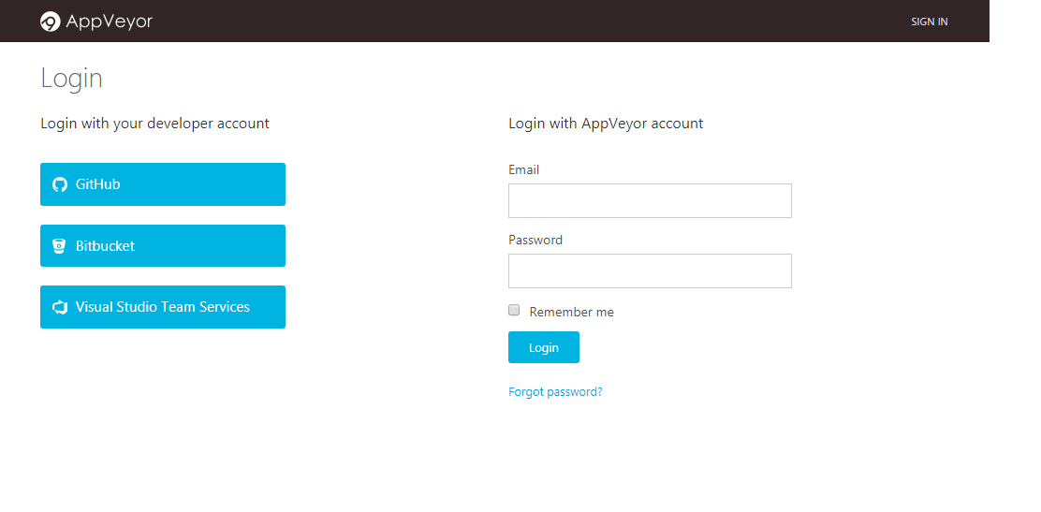

Authorize AppVeyor to access your account.

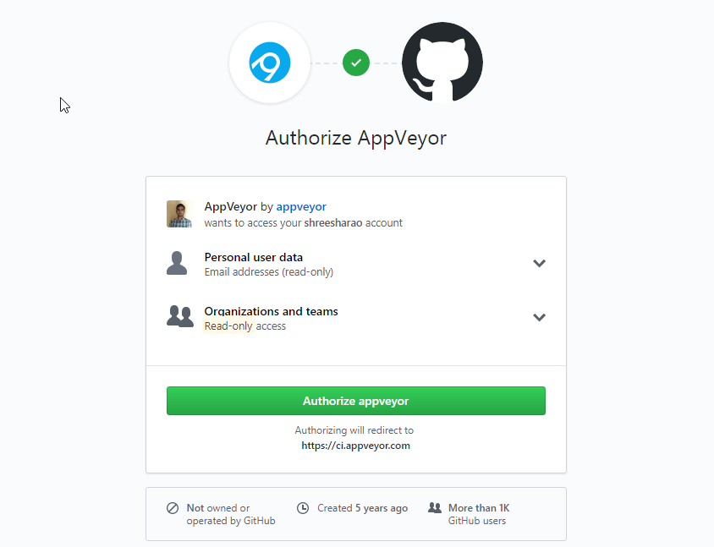

Create a project

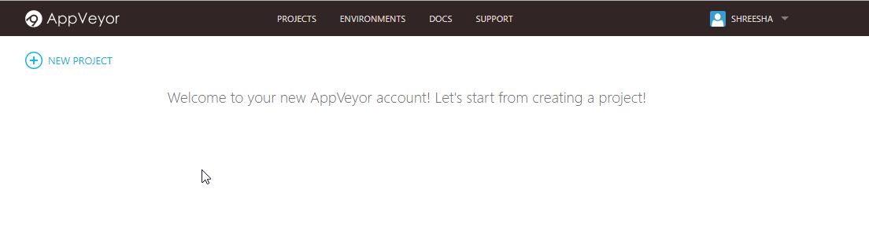

You will get many options to link your repositories. I wanted to link one of my github public repositories.

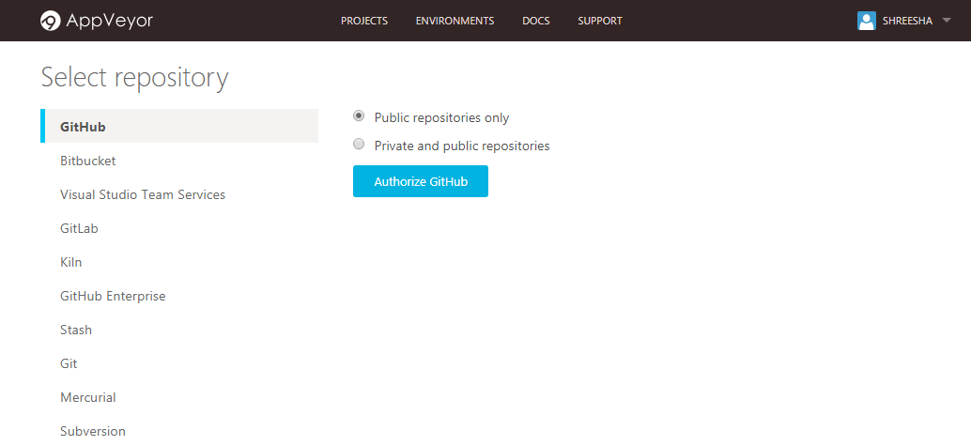

Authorize AppVeyor

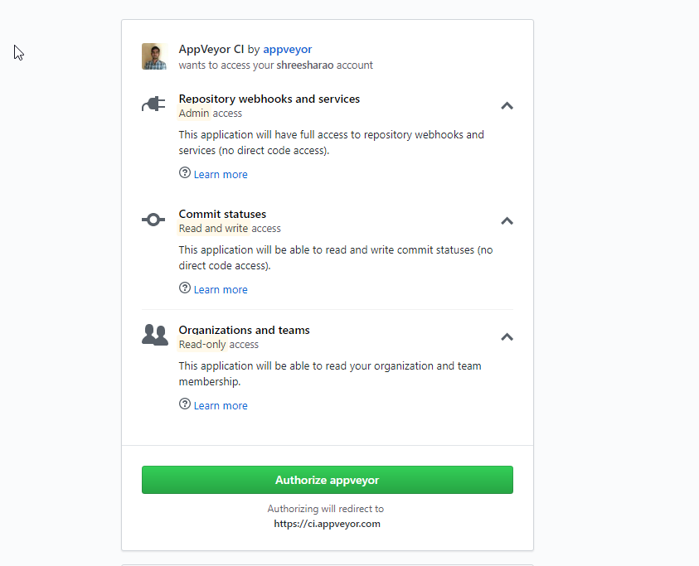

AppVeyor will list down all the public repositories. Choose the one you want.

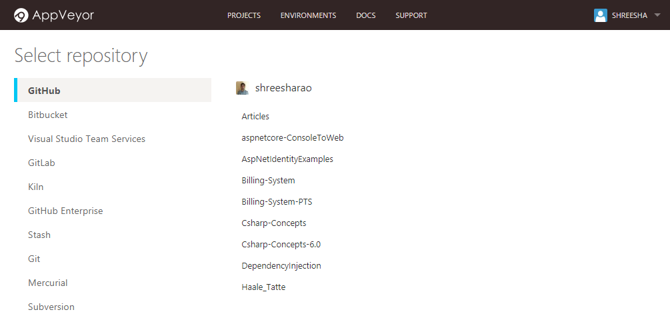

You can start a new build by clicking on ‘New Build button on the right hand top.

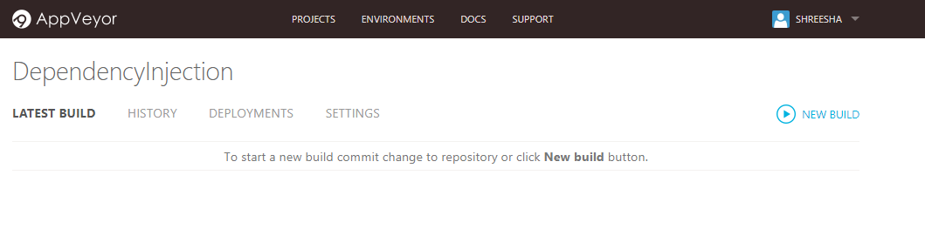

AppVeyor pulls you latest code and builds it!

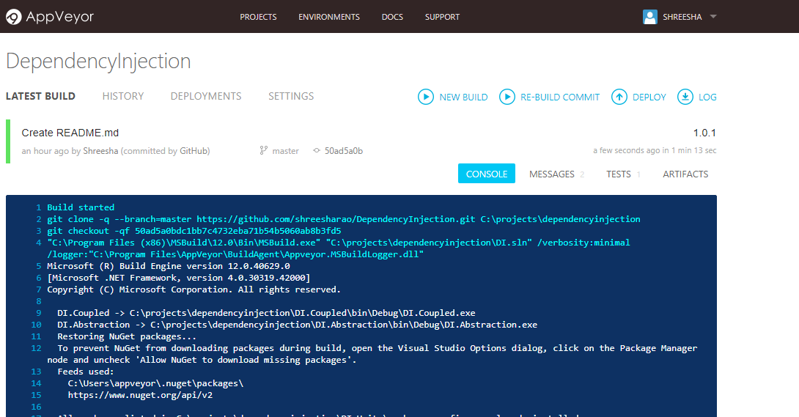

All test cases are also taken care!

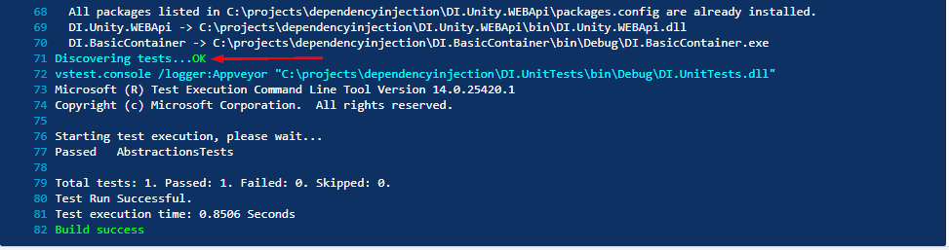

If there are any warnings you can see that in Messages tab on right hand side

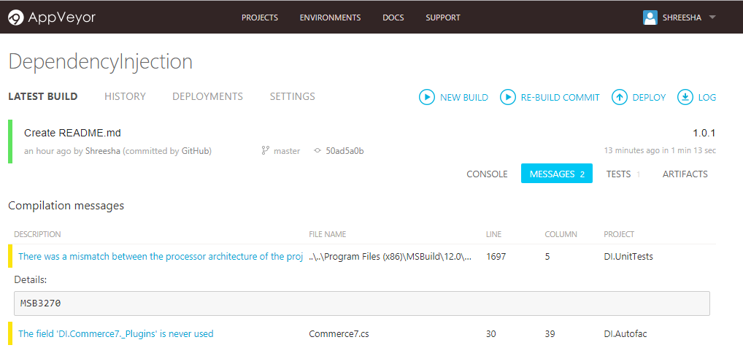

If your repository contains more than 1 project, then go to Settings > Build tab and Under visual studio solution or project file add the project file you want to build. As you see below Automatic packaging is also available.

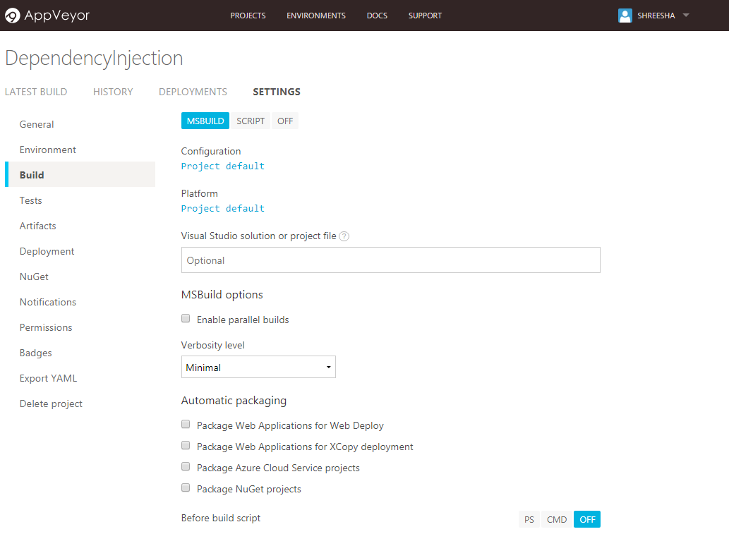

Now you can add a build status badge to your github project to ensure everything is right.

* Go to badges in project > settings section
* Copy Branch sample markdown code URL to readme.md

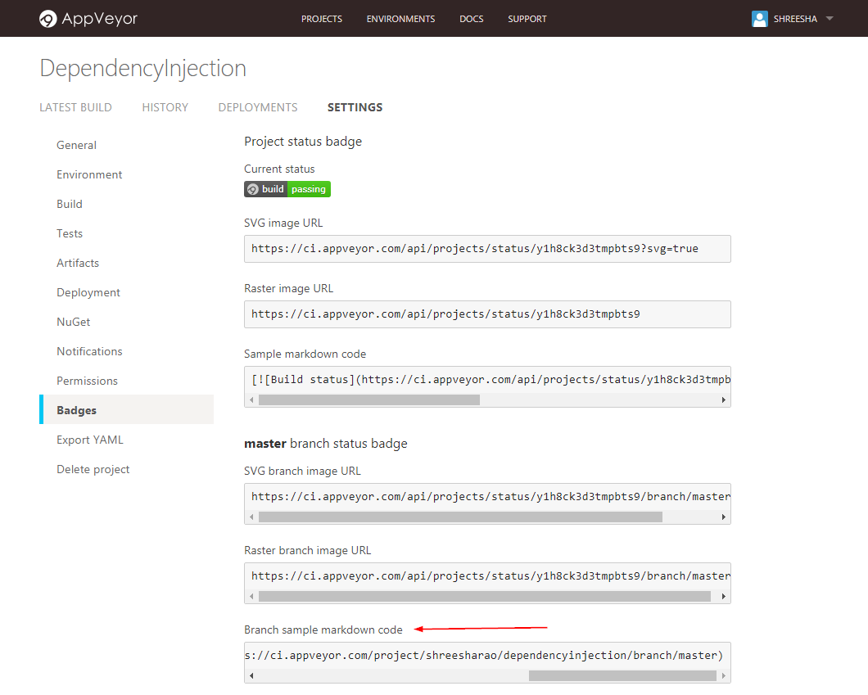

As you can see my repository readme is showing the build status

